(Approx. 819 words)

The Mac Corner – June 2014
Danny Uff, Lehigh Valley Computer Group, Pennsylvania
June 2014 issue, The LVCG Journal
www.lvcg.org
danny.uff (at) gmail.com

Before I begin, yes, this is The Mac Corner, and yes, I do work on Macs all the time.

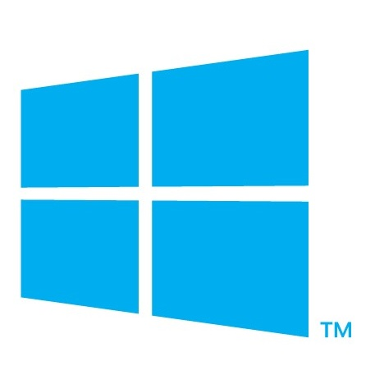
But last month, I did something that I swore I would never do again...... I bought a Windows 8.1 computer. Yes, I finally ran into a brick wall with the Mac and HAD to go back to the "enemy" again.

So, now that I got that out, what is it like going FROM a Mac to a Windows box? Since this is a family oriented newsletter, I'll keep it clean. It's like going FROM a 2014 Mercedes to a 1975 Beetle.

The biggest obstacle going from a Mac to a Windows machine is getting used to the new Windows 8 Tile structure. Even though the layout may work with Touch-screens, it doesn't work that well with a Mouse. The second biggest thing that took some getting used to is, not booting directly to the Desktop. Being an old Windows user (since Windows 3.0) it took me a while to get used to the new tile layout.

So, in closing, I can hear some of you readers saying "I told you so!" or "Welcome back to the real world." But like the old saying goes "You CAN teach an old dog new tricks."

Oh, by the way, yes, I will still write about Macs in the coming months. :-)

P.S. This article was written on a Mac!!!!!


The Mac Corner – July 2014
Danny Uff, Lehigh Valley Computer Group, Pennsylvania

This is perhaps the earliest article that I have ever written for any newsletter. But the experiences I had today when I ventured into the world of Windows 8 again, reminded me why I went (and stayed) with Macs all these years.

This article will be for both Macs and Windows users. For those of you in the world of Windows, please feel free to get mad at me. For those who are in the world of Mac, please count your blessings that this doesn’t happen to you yet. At the same time, if the Windows world doesn’t get too mad at me after reading parts of this article, perhaps you can learn how to keep my experience from happening to you.

While I was using my Windows box, I downloaded a program that would assist me with my project. A program from a reputable software company. Before I installed it, my computer (supposedly) checked it for known viruses and Malware, and then gave the ok. When I installed it, I then noticed these other icons coming on to my desktop. Icons that I didn’t ask for, nor even knew that were included inside the installer. So, I had to remove them (one by one) with the Add/Remove option. After that, all seemed fine - but it wasn’t. I then used Internet Explorer, and low and behold these other “windows” came up. Windows that looked like they came from Windows 8, but weren’t. Windows such as “your computer is running slow, check now!” and “Checking for Malware…..Malware found!” Another one claimed that I needed a Java update. So, not knowing it, I started installing the update. About 2 minutes later, I realized that too was a “fake window” and was downloading some unknown program to my computer, so I (tried) stopping it, and then finally ended up doing an emergency warm reboot. When I got it back, other stuff started to pop up along the way. Mind you, this is only half of what I have experienced so far.

Now, how can YOU stay away from what I did? (By the way, these stupid pet tricks are now showing up on Macs too). Here are three simple steps to keep your computer safe:

- Always take your time when installing a new piece of software. Read all the installation windows and make sure it is installing the software that you want - even from a company you trust.
- When receiving a notice that you need an update, do not click on the notice window. Exit out of it and go to the actual company’s web site and make sure that the update is real.
- Keep your virus scanners up to date (yes, I hate to say it: even on your Mac). These spammers are finding very creative ways to get your attention and even download stuff in the background.

Hopefully this little rant will help you to not fall into the same trap as I did. If you have a friend or a family member that claims that there computer is acting strange or slow, and they’ve installed some software that they didn’t know about…Please believe them. Because I have been in the PC and Mac fields for more than 30 years and even I got fooled.

